File 17_azone_relative_employment.csv
April 15, 2026
Definition of the Input File
The meaning of the attributes in this file was surprising to the research team.
Interpretation 1
In its summary, VisionEval (https://visioneval.github.io/docs/model-inputs.html) explains that this file “contains ratio of workers to persons by age” which would lead one to suspect that the attributes should be less than 1.0 for all age groups and especially for young children. However, this is not the case. In a more detailed section, the documentation explains that this CSV file “contains the ratio of workers to persons by age cohort in the model year relative to the model estimation data year” (emphasis added).
For example, for the attribute “RelEmp15to19” the definition is “Ratio of workers to persons age 15 to 19 in model year versus in estimation data year.” In other words, suppose 30% of persons age 15 to 19 work in 2024. The proper value for this attribute is not 30%. Instead, one needs to ask “what proportion of persons age 15 to 19 in 2045 will work?” and then compare that proportion to the 2024 proportion. Thus if analysts believe that 30% of persons age 15 to 19 in 2024 work and that this ratio will be 30% in year 2045, then the ratio should be 30%/30% = 1.0. Indeed in the sample data associated with RVMPO, the values are 1.0 for all age groups.
Table 1. Explanation of Azone_Relative_Employment from the VisionEval Documentation
Geo | Year | RelEmp15to19 | RelEmp20to29 | RelEmp30to54 | RelEmp55to64 | RelEmp65Plus
RVMPO | 2010 | 1 | 1 | 1 | 1 | 1
RVMPO | 2038 | 1 | 1 | 1 | 1 | 1

Interpretation 2
The document Task 7.2 Simplified Scenario Development guide, available at A Playbook for Simplified Approaches for Creating Scenarios in VisionEval suggests a different definition. The Guide states that this CSV file indicates “the proportion of persons in each age group who are in the labor force. For instance, the table suggests that in 2045, 90% of all persons aged 15 and above would be in the labor force.”
Table 3. Explanation of Azone_Relative_Employment from the Playbook
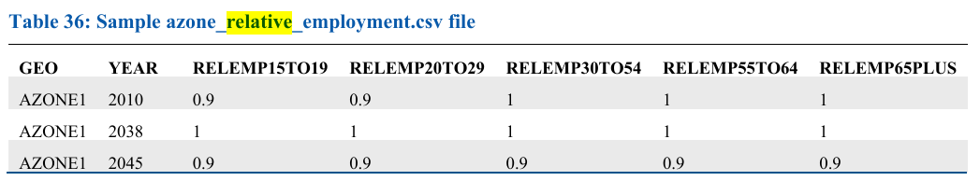
Choosing the Interpretation
Examination of another section of the VisionEval documentation, coupled with another sentence in A Playbook for Simplified Approaches for Creating Scenarios in VisionEval, leads the research team to believe that materially the first interpretation should be used. The VisionEval documentation at VisionEval/sources/modules/VESimHouseholds/inst/module_docs/PredictWorkers.md at main · VisionEval/VisionEval · GitHub states the following where the preceding paragraph had indicated, for a particular household, that there was a 70% probability that a person age 20-29 was a worker:
If the user has supplied optional inputs for the ratio of employment for the age group in the forecast year relative to the year of the model estimation dataset, that input is multiplied by the estimated worker probability to determine the sampling probability. For example, if the year of the model estimation data is 2000 and the forecast year is 2010, and if the user specifies that the employment rate of 20-29 year olds in 2010 was 95% of the employment rate of that age group in 2000, then the worker probability in the example above (0.7) is multiplied by 0.95 to calculate the sampling probability. (emphasis added).
In other words, if the user thought that the ratio of workers to households would remain constant from the base year to the forecast year, then value in azone_relative_employment should be 1.00 rather than 0.95.
It is possible that A Playbook for Simplified Approaches for Creating Scenarios in VisionEval nonetheless supports the first interpretation. A final sentence is included therein, which states that this file “is intended to be an adjustment beyond the ACS PUMS data used to create the synthetic population.” In that sense, if the ACS PUMS data presumes a certain ratio of workers to persons in an age group, and the analyst believes this ratio will change, in a forecast year, then presumably a number other than 1.0 could be used.
However, to be clear, the numbers in this file do not indicate the actual ratio of workers to people—rather, they indicate how that ratio will change. As an example, Virginia data from the U.S. Census Bureau reported by the Office of Intermodal Planning and Investment that for year 2021, of the 1.096 million persons age 54-65 living in Virginia, about 736,000 of them are in the labor force, for a ratio of 67.1%. If it is assumed this ratio will not change—that is in 2045 it will be the case that 67.1% of persons in this age group are in the labor force—then the value of 1 is retained. This is the assumption for Charlottesville and Albemarle below.
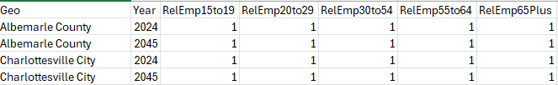
Possible Scenario
One possible scenario in VisionEval based on this input file is to examine how changes in relative employment affect travel demand. For example, in year 2045 perhaps more or fewer seniors will be employed. One could use a value of 0.90 to say that fewer seniors will be working year 2045 and thus examine changes in DVMT.”
Method Used for Virginia
For the base case, a value of 1 was used for the base and forecast year.

Appendix
- The research team used the percent of people in the labor force under the presumption that while unemployment may never be 0%, the labor force is an indication of people who will in some form be generating travel demand.
- That said, in the example above, if one wanted to use persons employed rather than persons in the labor force, then the percentage would be 64.9% rather than 67.1%.

Scrap work
Virginia Employment Status of the Population by Sex by Race and by Age by Year - Dataset - Virginia Open Data Portal
https://data.virginia.gov/dataset/virginia-employment-status-of-the-population-by-sex-by-race-and-by-age-by-year

